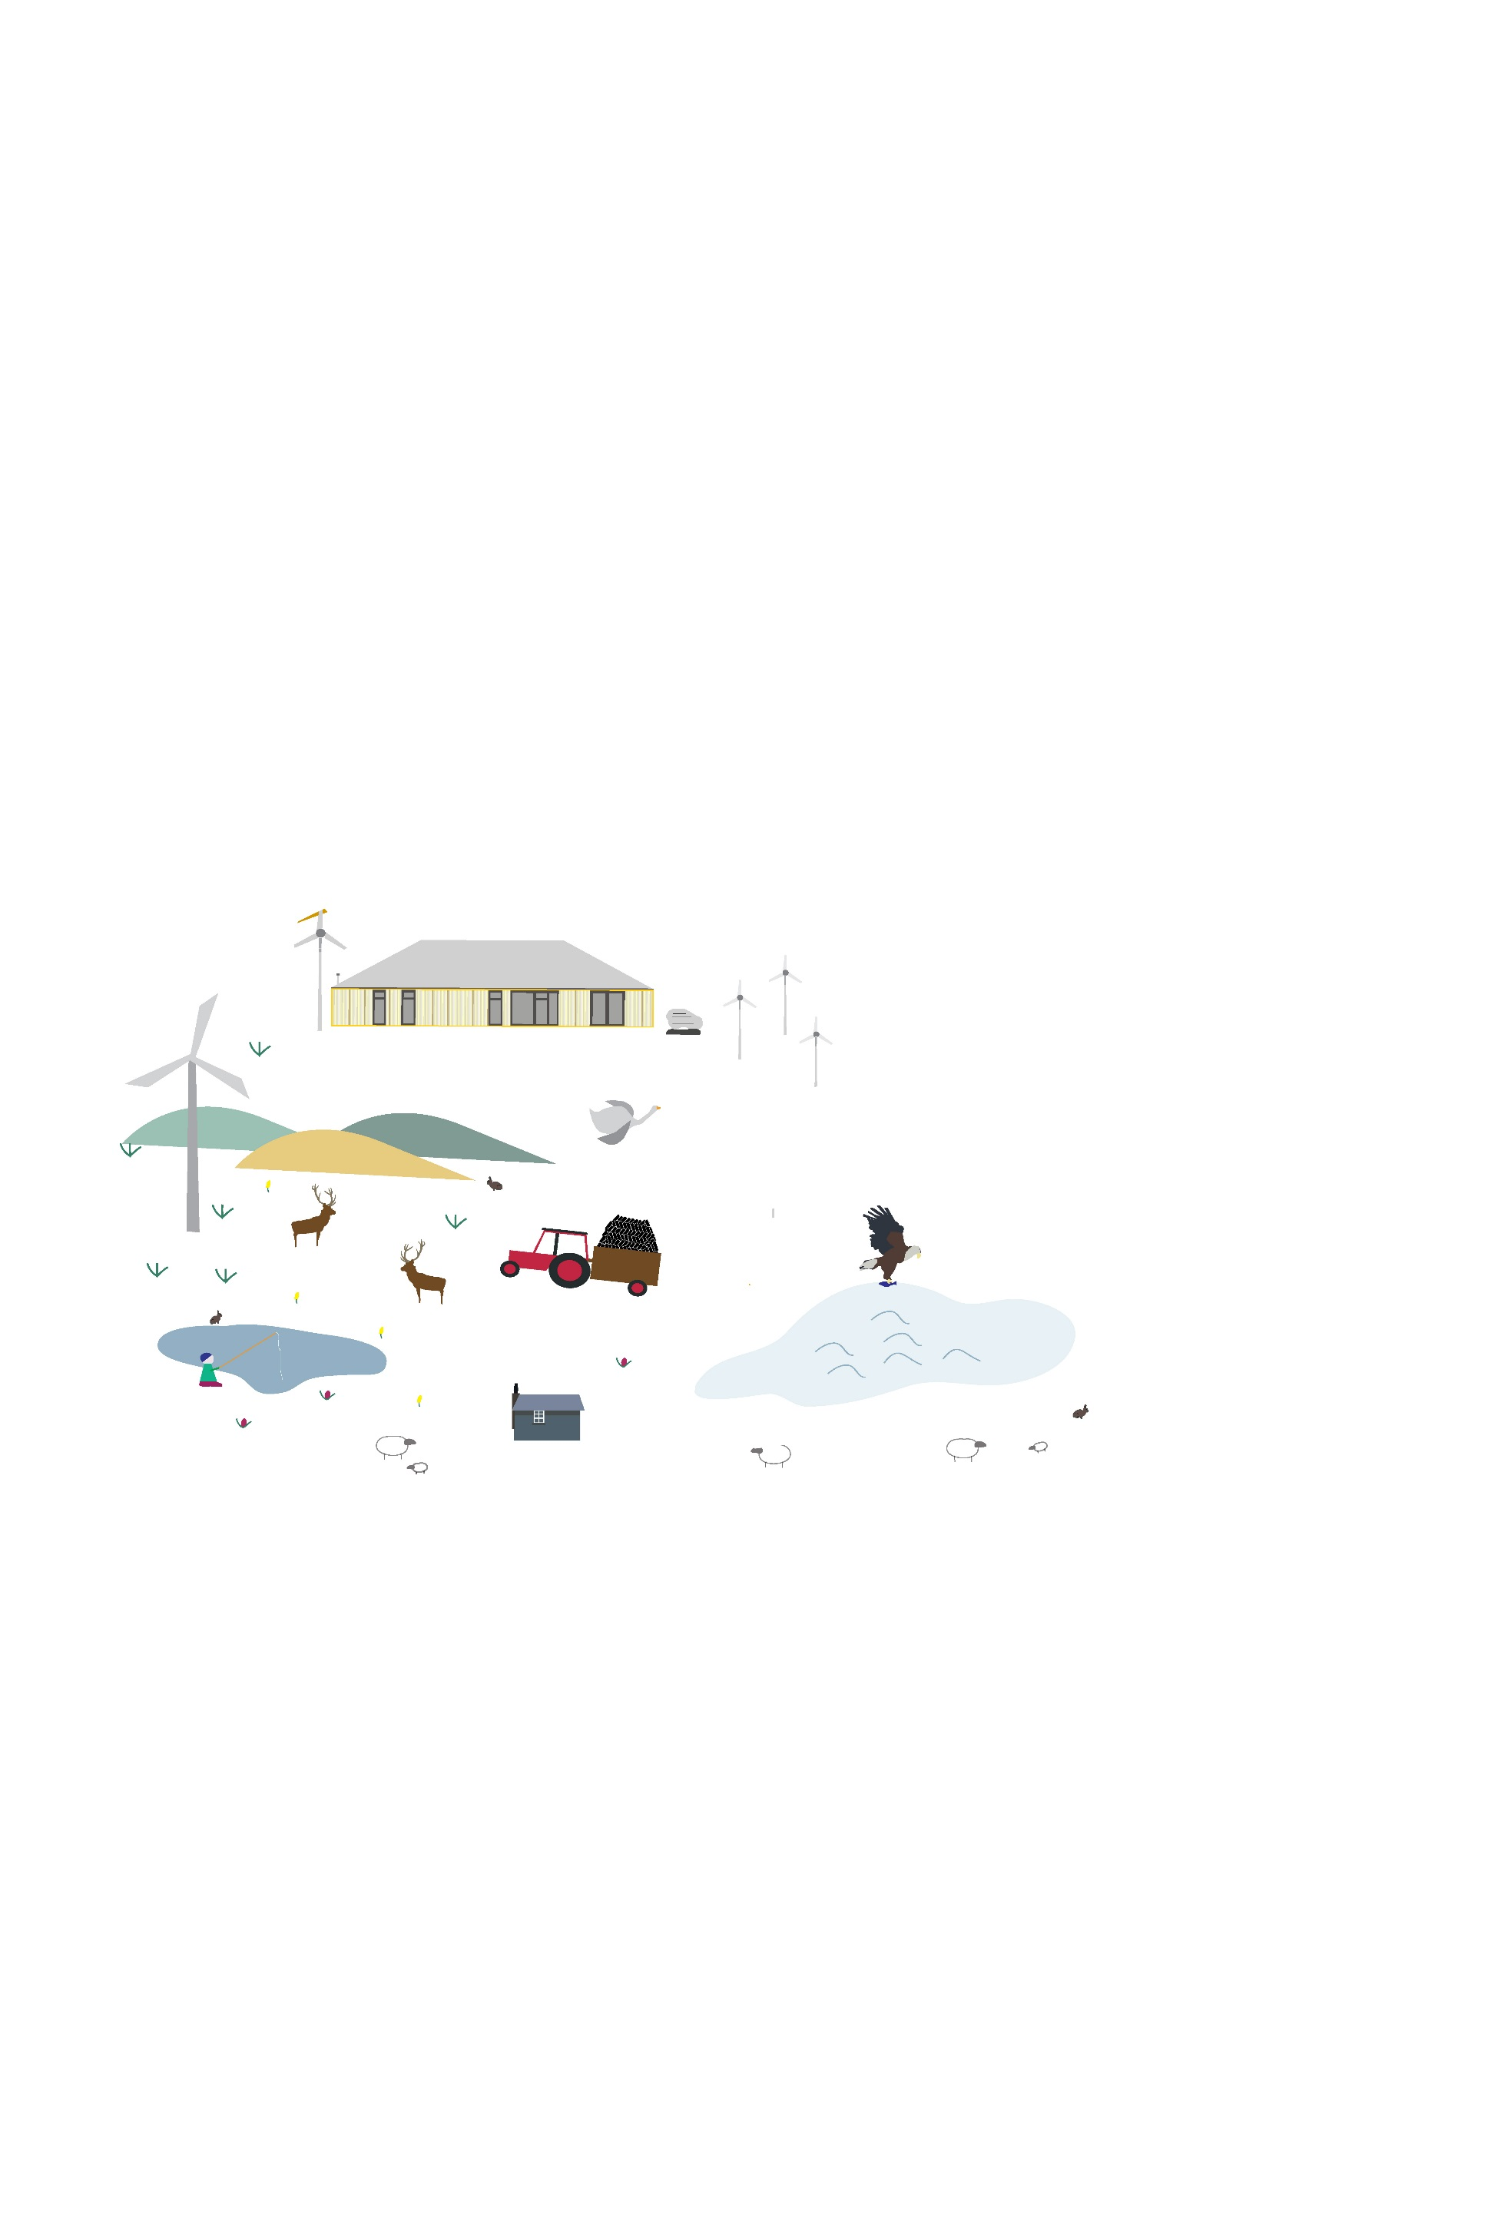

Urras Oighreachd Ghabhsainn (Galson Estate Trust) is entrusted with the management of the 56,000 acre, community owned Galson Estate covering the majority of North Lewis. North Lewis is a beautiful and important place for natural, built and social heritage with unique interactions between crofting lifestyles, beautiful landscapes and a diverse natural environment.

Do you live within the Galson Estate Trust for nine months of the year and want to get involved with the community, support local development and sustainable environmental management? If **YES** why not become a member of the trust for only £1.

As a member you will receive:

  The right to vote

  Opportunities to have your say

  10% discount for Urras events and workshops

  Discounted rate for UOG Business Centre hire

  Favourable table rates at Urras markets

  Volunteer opportunities

  Newsletters posted to your home

Simply fill in the form on the back of this slip and return to the Urras Oighreachd Ghabhsainn, along with your joining fee of £1 (for life).

**BECOME A MEMBER**

Recruiting new members and providing ongoing benefits for existing members is a vital part of Urras’ work. It is very important for the trust to grow, helping to ensure a vibrant engaged community.



**Membership form**

Joining fee £1 (for lifetime membership).

**NAME**:……………………………………………………………..…..……………………………………………………..

**CROFT NO (if applicable):** …………………………………….…………………………………………………….

**ADDRESS:** ……………………………………………………...……….……...............................................

**POSTCODE**:..…………………………………………………………………................................................

**TEL NO:**………………………………………………………………...……………………………………………………

**EMAIL**:…………………………………………………………………………………………………………………………

You will automatically be added to our mailing list, to opt out please tick here 🞏

Are you aged 16 or over (please circle): **Yes /No**

**Please tick** one of the following categories:

1.  I am resident within the Galson Estate Trust 🞏

2.  I am resident within the Isle of Lewis & registered with the Crofters Commission as

the tenant of a croft within the Galson area. 🞏

3. I am resident elsewhere and registered with the Crofters Commission as the tenant

of a croft within the Galson area and I am actively working that croft. 🞏

I wish to apply for membership of the Urras and I agree to abide to the conditions of membership. I enclose my entry fee of £1.

**Signed** ………………………………………............................................. **Date** ……………………………….



**For more information contact us:**

Address: UOG Business Centre, Tom na Ba, South Galson, Isle of Lewis, HS2 0SH

Tel: 01851 850393

E-mail: office[@uogltd.com](mailto:amy@uogltd.com)

Website: [www.galsontrust.com](http://www.galsontrust.com)